Comments By Robert Weinreb (b: 15 Jan 1943) on The Weinreb Family in 1916 Europe
Oct 1, 2014
While going through old prints we discovered the 2 pictures.
The below photo has the title "Turka am Strj Summer 1914".
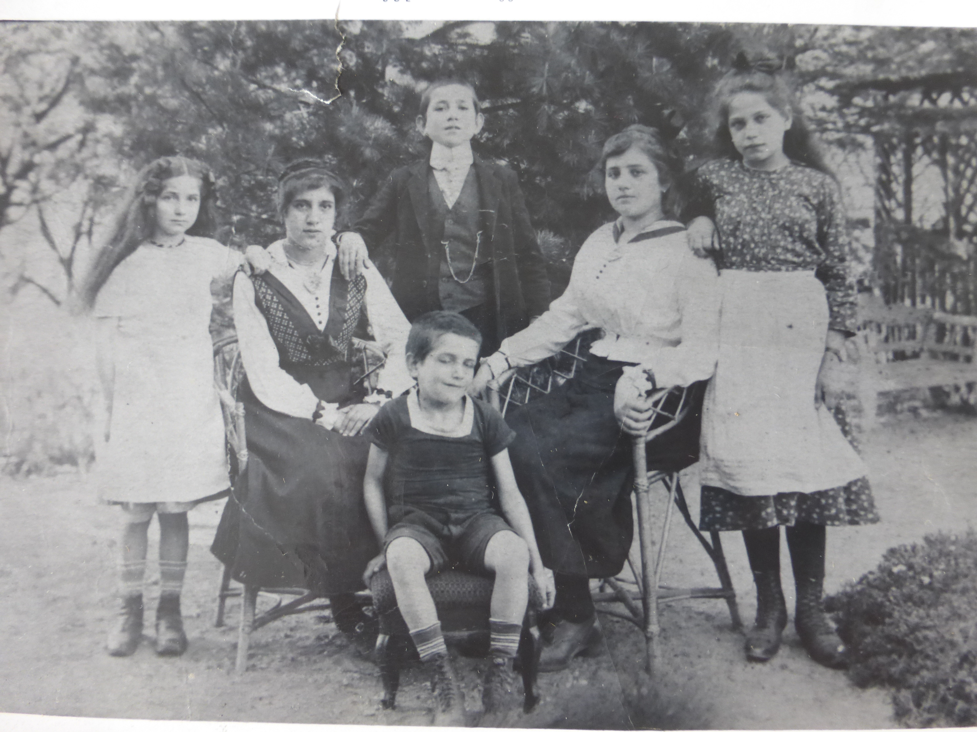
The children of Rose Wolf (b: 1869, d: 1936) and Avrum Mordecai Weinreb (Avrum Mordecai Weinreb) are from left to right Evelyn, Tobie, Morris, Sallie and Ethel. Joe is below Morris.
Googling (how else do we learn anything these days) Turka am Strj I found an extensive history.
The site is www.jewishgen.org/yizkor/turka/tur025
Turka was founded as part of Poland in the 1450’s and was in a dense forest, ( where the King of Hungary wandered lost for 4 years trying to find his way home ( if you can believe it)
Jews arrived in 1730 as I remember and it was a very poor area. In 1903 the railroad came through and lumbering started.
In 1903 40% of the population was jewish, 40% polish and 20 % polish nobility or something else.
Lumbering and sawmills were the major industry. All but 3 of the sawmills were Jewish owned
I remember that our Grandfather was running a saw mill and or a lumbering operation.
In 1914 the war came via a Russian Patrol.
An Austrian patrol responded, arriving by train and shot up the Russians.
The Russians returned in force, looted and burned the town, raped the women and girls that they could find and the population took off leaving everything behind fleeing to Hungary and Solvakia.
I would believe that this is when our family fled and started their life as refugees, caught between the lines.
I remember my father Joesph, saying that as a 6 year old he was very good at foraging in the woods for berries and mushrooms.
So this picture is of them happy, and prosperous, before their world collapsed.
Stryj is a river. The town is still called Turka.
Now it lies in the south west corner of Ukraine
It was part of Austria until after the 1st world war. Then it went to Poland. After WW2 it became part of Russia.
This below photo has the title "Mother Rosa Weinreb, Austria 1916", which is my grandmother.
