THE FAMILY OF AVRUM MORDECHAI WEINREB:
FROM GALICIA TO AMERICA

By Dr. Fred Ederer, born 1926
Written June 1, 2005; Updated Feb 26, 2012 by gsw

I am a Weinreb by marriage. My wife, Hilda Tomar Ederer, is the daughter of Ethel Weinreb Tomar, who was the daughter of Avrum Mordechai Weinreb. Having become enveloped in this family’s unusual closeness, I feel like a Weinreb myself. Upon viewing the Weinreb family history website (1), including the extensive genealogy, I thought it would be worthwhile to collect what information we can about the history of the family of Hilda’s Weinreb grandfather, as limited as that knowledge currently is, and as regrettable as is our failure to get more information from the previous generation. Better late than never! Some of the following is from documents, which will be cited, and much of it is oral history I obtained from Hilda, Ethel, and Hilda’s first cousins Leslie Baker, Ben and Sander Weinreb, and Thelma Bialer.

As shown on the Weinreb genealogy (2), Avrum Mordechai Weinreb (1866-1939) and his wife, Rose Wolf (1869-1936), had nine children: Mary (1892-1986), Harry (1894-1983), Celia (1896-1984), Tobe (1898-1918), Sallie (1900-1946), Maurice (1902-1982), Ethel (1904-1991), Evelyn (1906-1992), and Joseph (1908-1996). The family originated in Galicia, then a part of the Austro-Hungarian empire ruled by the Habsburg emperors, and emigrated to the United States between 1908 and 1920. The three oldest children, Mary, Harry, and Celia emigrated before the first World War (August 1, 1914-November 11, 1918). The rest of the family, except for Tobe, who died in the 1918 influenza epidemic, emigrated in 1920.

The Habsburg empire stretched from Galicia, which together with Bukovina formed its eastern frontier, to South Tyrol. Today these territories occupy all of the Czech Republic, Slovakia, Hungary, Slovenia, Croatia, Austria, a part of Poland, the Bukovina region of Rumania, the western part of Ukraine, and a large segment of northern Italy (Alto Adige). Eastern Galicia was largely inhabited by Ukrainian peasants, who spoke Ukrainian or Ruthenian, a Ukranian dialect, and was ruled by Polish gentry. Western Galicia was inhabited by Poles. The legal and school language throughout Galicia was Polish. Under tolerance patents issued in 1792 by Emperor Joseph II and in 1867 by Emperor Francis Joseph I, who ruled from 1848 to 1916, Jews and non-Jews who lived under the Habsburgs had basic human rights, including suffrage, the right to education, and freedom of belief and of residence. In 1918 the Habsburg empire collapsed, with western Galicia becoming a part of Poland, a new nation, and eastern Galicia a part of the Soviet Union, established in 1917. After the collapse of the Soviet empire in 1991, eastern Galicia became a part of the republic of Ukraine, a new nation. A brief history of Galicia and maps are provided at the Weinreb family history website (1).
Below is a 2012 map that shows Przemysl and Turka, two cities that were inhabited by Weinreb's before WW1. As of 2012, these cities are in Poland and Ukraine respectively; and are both on the Ukraine/Polish border.
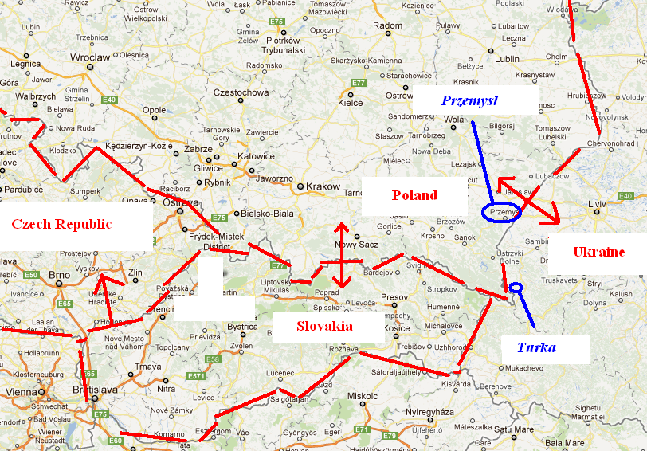

Hilda tells me that she learned from her mother that her grandfather Avrum Mordechai had come to the United States alone before the first World War, with the aim of starting a business involving safety pins. When the effort failed, he returned to Galicia. The Ellis Island records (1) show that Avrum Mordechai’s first trip to America occurred in 1896, when he was 29 (his second and last trip was in 1920). We have no record when he returned from his first trip, but, given that his nine children were all born at intervals of two calendar years from 1892 to 1908, he must have returned to Galicia within two years. When Avrum Mordechai left for America in 1896, his wife Rose may have been pregnant with Celia.

Some four and a half decades ago my father, who was born in Buczacz, Galicia, asked Ethel where she was from. She said “Turka am Stry” (Turka on the Stry river) in the Carpathian mountains. (Throughout, I am using the Polish spellings of Galician names that were used under the Habsburgs, although German spellings were also used for prominent places like Cracow (Krakau), Lwow (Lemberg) and Stanislawow (Stanislau). Ethel also said that the family moved around because the lumber business required it. Notes that Sander Weinreb took while interviewing his parents some years ago indicate that his father Maurice had lived in Przemysl and Krechowitz, which are in Galicia, and in Leitmeritz, which is in the Sudetenland, a part of Bohemia. Ethel, who was born in Krechowitz, was only about 9 years old when the family left Galicia in 1915 (her brother Maurice was about 11 then), and it may be, that of the various Galician places where the family lived, she remembered Turka best because it is the last place where they lived, or the place where they lived the longest, or both. Turka, Przemysl, and Krechowitz are in western or central Galicia; Kosowa and Brzezany, where the family of Avrum Mordechai’s brother Israel Ben Zion lived, are in eastern Galicia. on a copy of a few pages from a 1905 edition of Baedeker on Austria-Hungary. On a map of Galicia, on a page copied from a 1905 edition of Baedeker on Austria-Hungary that was sent to me by a librarian, we were able to find Krechowitz 40 miles north-west of Stanislawow.

Ben Weinreb has pointed out that the Ellis Island Records website (3) provides immigration records of most members of the Avrum Mordechai family. Mary was the first of Avrum Mordechai’s children to immigrate, but no Ellis Island exists record for her immigration. Leslie Baker states that her mother told her that she arrived in the United States at age 16. If the year of her birth, 1892, on the family tree (1) is correct, then Mary arrived in the US in 1908 or 1909, but only one teen-aged female Weinreb came to Ellis Island from Galicia or Austria in 1907-1910, a Brane Weinreb, who came from Chodorow in 1907 at age 17. The age is close enough for Brane to be Mary, because the ages on the immigration records, which were provided by the immigrants, are not precise. But Chodorow is not a place name known to any current member of the Weinreb family. This leaves open the possibility that Mary entered the US at another port, like Philadelphia or Baltimore. But this also seems unlikely, because Mary was headed for New York, not Philadelphia or Baltimore, and before WWI there was frequent ship traffic from Europe to New York by more than two dozen liners from England, France, Germany, Holland, and the US. Why there is no Ellis Island immigration record for Mary Weinreb remains a mystery.

The Ellis Island records cite the immigration from Turka, Austria in 1910 of a Herman Weinreb, age 17, and in 1912 of a Czarna Weinreb age 18. Are these Harry and Celia, respectively? The ages don’t quite match. If the birth years from the family tree are correct, then Harry, born in 1894, would have been only 15 or 16 in 1910, and Celia, born in 1896, would have been only 15 or 16 in 1912. But, as we have said, the Ellis Island ages are not precise. Harry is an English name that was not likely to have been used in Galicia, and Czarna is not a name that Celia would likely have kept in this country, so it is plausible that Harry’s name in Galicia was Herman, and Celia’s name Czarna. That Herman and Czarna are indeed Harry and Celia is confirmed by their ships’ manifests showing, in each case, that Markus (sic) is their father. In Herman’s case, the manifest lists Getzel to be his uncle. In Europe and America Avrum Mordechai used, for official purposes, the first name Marcus (sic); Getzel Weinreb was the youngest of Avrum Mordechai’s six siblings (2).

The remainder of the Avrum Mordechai Weinreb family left the war zone of Galicia in 1915, and moved to Leitmeritz in the Sudetenland, an Austro-Hungarian region in northern and western Bohemia and northern Moravia in the vicinity of the Sudeten mountain ranges. The Sudetenland at that time, and until 1945, was largely inhabited by the German-speaking Sudeten-Germans. After WWI, Bohemia, along with Moravia and Slovakia, formed the new republic of Czechoslovakia. The country was occupied by Nazi-Germany In 1938-39, and became independent again after WWII, at which time the German-speaking population was expelled. In 1993 Czechoslovakia split into two nations, the Czech Republic and Slovakia. Leitmeritz (a German name--in Czech it is Litomerice) is about 45 miles north of Prague.

Hilda’s mother’s German-language records from the school she attended in Liebeschitz in the Leitmeritz school district show that she was born in Krechowitz, and that she entered that school on November 4, 1915 (when she was 10). We may infer from this that the family fled from Galicia in the fall of 1915, a year after the war broke out. Stan Baker, Leslie Baker’s husband, indicates that in 1914-15 Galicia was a major theater of war for Russia, Germany, and Austria, was initially occupied by the Russian army, and subsequently returned to Austrian hands for 1916-18. This raises a question. Where were the Weinrebs between August 1914 and November 1915? Under Russian occupation? That seems unlikely, because we would have heard about it. At the outbreak of war they may have lived in Turka, in western Galicia, away from the fighting, at least for the first year of the war, and then fled to the Sudetenland when the fighting came closer.

Ethel received from the school in Liebeschitz annual school certificates, and on 13 August 1918 (her 14th birthday), an Entlassungszeugnis (school leaving certificate) "because she had completed the legal school requirements." The school records are signed by the principal, the teacher, and Ethel’s father (“Marcus Weinreb”). Ethel’s behavior in school was graded "praiseworthy," and her industriousness "persistent." In 10 of 14 subjects she was graded "sehr gut" (the top grade), and in the other 4 "gut" (the next highest grade). The 10 subjects in which Ethel achieved “sehr gut” consisted of a spectrum of academic subjects, as well as “feminine handicraft,” which probably included needlework, and possibly knitting, and crocheting. The four subjects in which she achieved a “gut” were handwriting, drawing, singing, and physical training. (The lower three grades, of which Ethel received none, were “genuegend” (adequate), “kaum genuegend” (barely adequate), and “nicht genuegend” (inadequate)).

Hilda has from her mother an autograph book, which Ethel kept from 1917 to 1920. A number of the entries are “Zum Andenken” (in remembrance), and some include a poem. The entries are from her sisters Toni (Tobe), Sali (Sallie), and Jadwiga (Evelyn), her cousin Berthe (Bertha), and numerous friends. An entry in memory of Toni (Tobe) gives her dates of birth and death. There is also an entry in 1947 from Ethel’s son Russell, who was then 10 years old. Most of the entries are from Liebeschitz, a few from Tarnow. The earliest Tarnow entry is dated February 15, 1919.

The war ended in November 1918, and in the next few months, not later than February 1919, the Weinrebs (except for the older children, who had left for the US before the war, and possibly without Tobe, who died on November 25, 1918) left Leitmeritz for Tarnow, a city that had been in the western part of Austrian Galicia, and was now, as the rest of western Galicia, in the new republic of Poland. The Weinrebs evidently had to go to a Polish city to get passports, as they were now Polish citizens. In June 1920 the family emigrated to the US. Ethel's passport and the Ellis Island records show that they left Poland from Tarnow. The passport shows permission to travel through Germany between the 8th and 15th of June. In Ethel's handwriting, on a blank page, there is a German-language diary-like entry of the following dates:

Left by ship [on the T.S.S. Rotterdam] from Rotterdam 3 July
Arrived in Hoboken and disembarked 12 July
Left "Kesselgarten" [Castle Garden] 14 July
Went to 23 Rodney, Brooklyn 15 July

The Ellis Island website (3) confirms that Marcus, Rosa (Rose), Sala (Sallie). Moses (Maurice), Etka (Ethel), Jadwiga (Evelyn), and Josef (Joseph) arrived in the US from Rotterdam on the T.S.S. Rotterdam on July 12, 1920. Traveling to America with the family of Avrum Mordechai Weinreb on that same liner were three close relatives: Avrum Mordechai’s widowed sister-in-law Rachel (Israel Ben Zion's wife) with her two youngest children, Schaindele (Jennie) and Berta (Bertha). Israel Ben Zion had died in 1917.

The Weinreb genealogy (2) provides the complete birth dates of the younger children of Avrum Mordecahi. All indications are that these are correct. Below are shown the actual ages on July 12, 1920 of the four younger siblings, compared with their Ellis Island website ages. Each Ellis Island age is off by one or two years.

Actual Ellis Island website Website error
Maurice 17 15 -2
Ethel 15 17 +2
Evelyn 13 12 -1
Joseph 12 10 -2

In the United States two of the children of Avrum Mordechai, Sallie and Maurice, married their first cousins, Samuel and Bertha, the children of Israel Ben Zion.

The reasons for emigrating are not clear, but are more likely economic than political. Although there surely was anti-Semitism in Austrian Galicia, as there was, and still is today, in many parts of the world, it was not as blatant in Galicia as it was in Russia, where there were pogroms, and where there was discrimination against Jews by the state, such as residential and occupational restrictions. Jews in eastern Europe at that time saw America as the land of opportunity, “di goldene medine” (the golden country). The beginning of emigration of the Avrum Mordechai Weinreb family was signaled, in the waning years of the 19th century, by the patriarch’s unsuccessful effort to start a business in the US, and accompanied or followed by the emigration of his three oldest children. After the war ended, the promptness with which the family left the Sudetenland to head for a city where they could apply for a passport suggests that the decision for the entire family to emigrate was made during the war, if not before.

References

1. Weinreb Family History. http://www.weinreb.org/history/index.html

2. Descendants of Moses Weinreb.(1840-1897). Summary.
http://www.weinreb.org/history/genealogy/Weinreb_outline_descendant.pdf

3. Ellis Island Records. http://www.ellisislandrecords.org/

